# **ZOMATO RESTAURANT’S EXPANSION PROJECT**

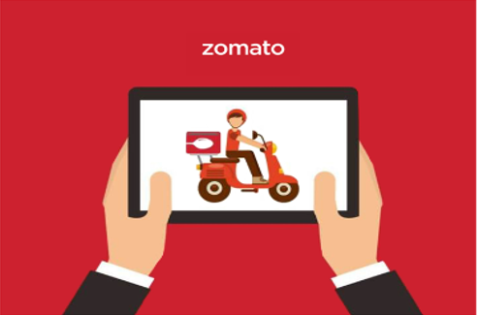

By: Kumar Prakash

**Objective Questions & Answers**:

1. **The data consists of some inconsistent and missing values so ensure that the data used for further analysis is cleaned.**

Answer: -

* Yes, Data is not clean. Like Average_Cost_for_two, Datekey_Opening.
* When we talk about Average_Cost_for_two – different country has value in different currency. So, it is very difficult to compare and find insights. So, I had converted all into USD ($) by using respective currency value in USD (Which is defined in Country description sheet) and one more column of name Average_Cost_for_two(In USD).
* When we talk about Datekey_Opening Year, Month & Day by using Text to Columns features of Excel.
* Also, in many rows we got Longitude & Latitude has value 0 for different Address. But I’m ignoring this case.
* The Answer is in **“Cleaned Data”** sheet.

1. **Using the Look-up functions, fill up the countries in the original data using the country code.**

Answer: -

* I’m using this formula (=VLOOKUP (C2,'country description'!$A$2:$B$16,2) in cell D2 and as follow in other column) to fill Country column with country with the help of country code.
* The Answer is in **“Cleaned Data”** sheet.

1. **Create a table to represent the number of restaurants opened in each country.**

Answer: -

* I had created table in “**Objective_question_answer”** sheet. Below I’m adding screenshot…
* Also, I had added Slicers in the sheet.

By: Kumar Prakash

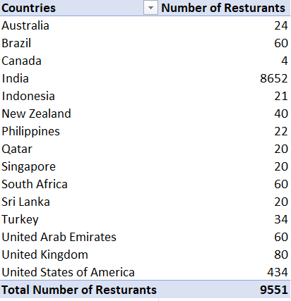

1. **Also, the management wants to look at the number of restaurants opened each year, so provide them with something here**.

Answer: -

* I had created table in “**Objective_question_answer”** sheet. Below I’m adding screenshot
* .Also, I had Slicers in the sheet.

By: Kumar Prakash

* 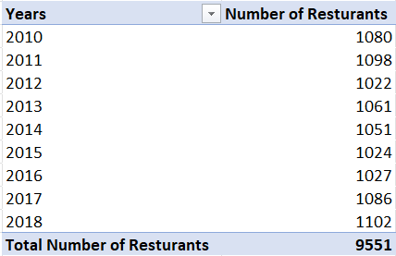

1. **What is the total number of restaurants in India in the price range of 4?**

Answer: -

* I had created table in “**Objective_question_answer”** sheet. Below I’m adding screenshot…
* Also I had added Slicers in the sheet.

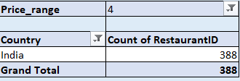

1. **According to the data, what is the average number of voters for the restaurants in each country?**

Answer: -

* I had created table in “**Objective_question_answe**r” sheet. Below I’m adding screenshot… Also, I’m round it to 0 decimal places.
* Also I had added Slicers in the sheet.

By: Kumar Prakash

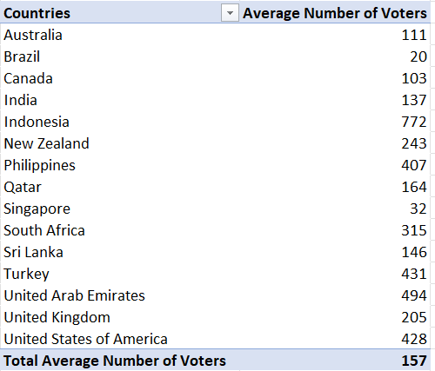

By: Kumar Prakash

**Subjective Questions & Answers**:

1. **Suggest a few countries where the team can open newer restaurants with lesser competition.**
   * I found Canda, Singapore, Australia and Sri Lanka are the countries to expand the restaurant business because apart from all the countries less number of restaurant with low ranting and there is no facilities of Online Delivery and Table Booking.
2. **Come up with the names of States and cities in the suggested countries suitable for opening restaurants.** 
   * For finding the cities suitable for opening restaurants or expanding food delivery business. I had created the pivot table with country and city in rows and filter with suggested countries in filter.
   * For more information you can refer “**Q1-Q2(Subjective)”** sub sheet.

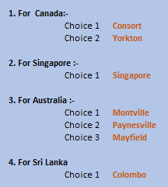

By: Kumar Prakash

1. **According to the countries you suggested, what is the current quality regarding ratings for restaurants that are open there?**
   * Canada, Singapore, Australia and Sri Lanka are good and can be improve by food quality control. Cloud kitchens or Online delivery for restaurant are beneficial for business in Countries.
   * I had created pivot table with country in rows & ratings in value with summarize the average. I filtered the countries with filter in pivot table.
   * For more information you can refer the sheet **“Q3-Q6(subjective)”**.

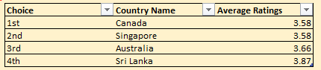

1. **Also, what is the current expenditure on food in the suggested countries, so we can keep our financial expenditure in control?**
   * To analyze the average expenditure on food in suggested countries, I created the pivot table by taking country in rows and “**average_cost_for_two(in INR)** “ in values and summarize by Average. I filtered the data with recommended countries with filter option and got the below table.
   * For more information you can refer sheet **“Q3-Q6(subjective”.**

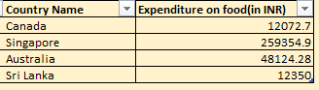

By: Kumar Prakash

1. **Come up with the names of restaurants from the recommended states that are our biggest competitors and also those that are rated in the lower brackets, i.e. 1-2 or 2-3.** 
   * To solve this question, I used pivot table solution by giving countries in rows, price_range in values as min & max.
   * Then I figured out the name of restaurant in cities that comes in 1-2 or 2-3 price bracket.
   * For more information you can refer sheet “**Q3-Q6(subjective”.**

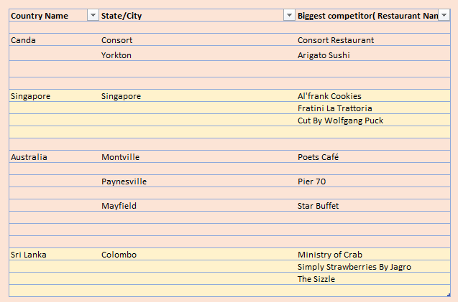

1. **Which cuisines should we focus on in the newer restaurants to get better feedback? Does the choice of cuisines affect the restaurant ratings?**
   * I created the pivot table with available cousins in restaurant and then created the chart for restaurants and available cousins in it.
   * Most ordered or available cousins in the countries I found from the chart are given below in table:
   * For more information you can refer sheet “**Q3-Q6(subjective”.**

By: Kumar Prakash

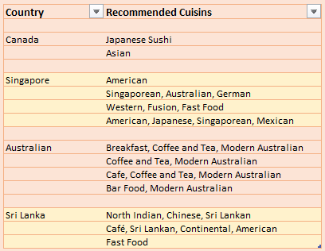

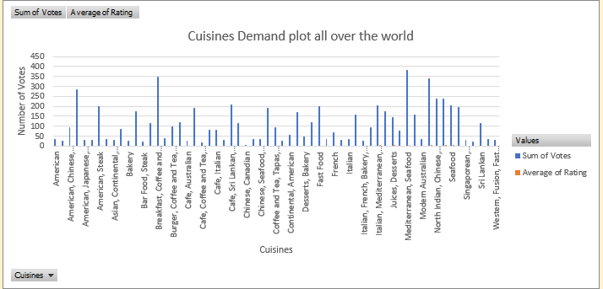

By: Kumar Prakash

1. **According to our current data, should we go for online delivery and table booking? Does that affect the customer’s ratings?**
   * In recommended cities, none of the restaurant is providing online delivery and less number of table booking facilities.
   * From the data It can be conclude that this technique will most affect on our business.
   * For more information you can refer sheet “**Q7-Q8(subjective)”.**

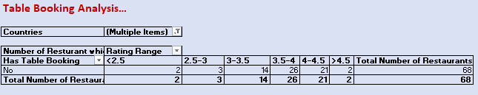

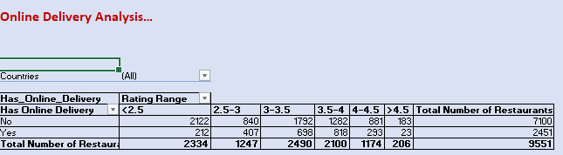

By: Kumar Prakash

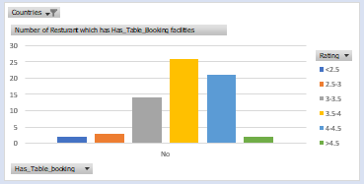

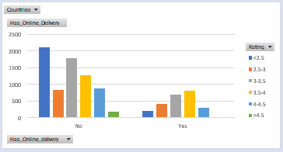

1. **Should the team keep the rate of cuisines higher? Will that affect the feedback? According to our data are the rates of cuisines and ratings, correlated?**
   * It depends on which cuisines are planning to sell.
   * If rating of cuisines is high in neighbor restaurant, then keep lower price rate.
   * If we are keeping most demanding cuisines all over the world, then keep moderate price rate.
   * Try to keep price rate lower as compare to other restaurant at initial level, after customer attraction and feedback, we can change the rate(increase or decrease).
   * But one thing not compromise with quality.
   * For more information we can refer sheet “**Q7-Q8(subjective)”.**
2. **What is the distribution of number of restaurants of different price ranges in all the countries?**
   * I solved this question by creating the pivot table. I took price bucket as in rows and percentage of total number of restaurant in column.
   * For more information we can refer sheet “**Q9(subjective)”.**

By: Kumar Prakash

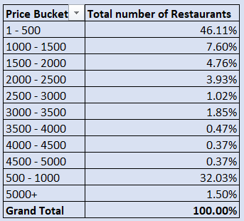

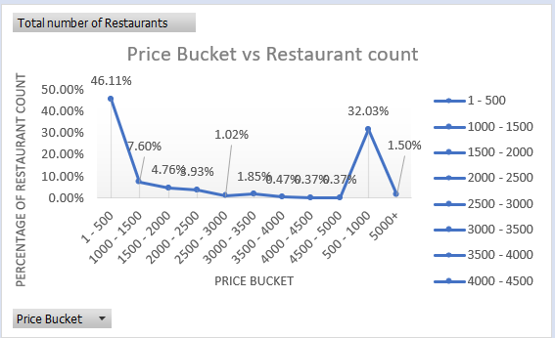.

By: Kumar Prakash

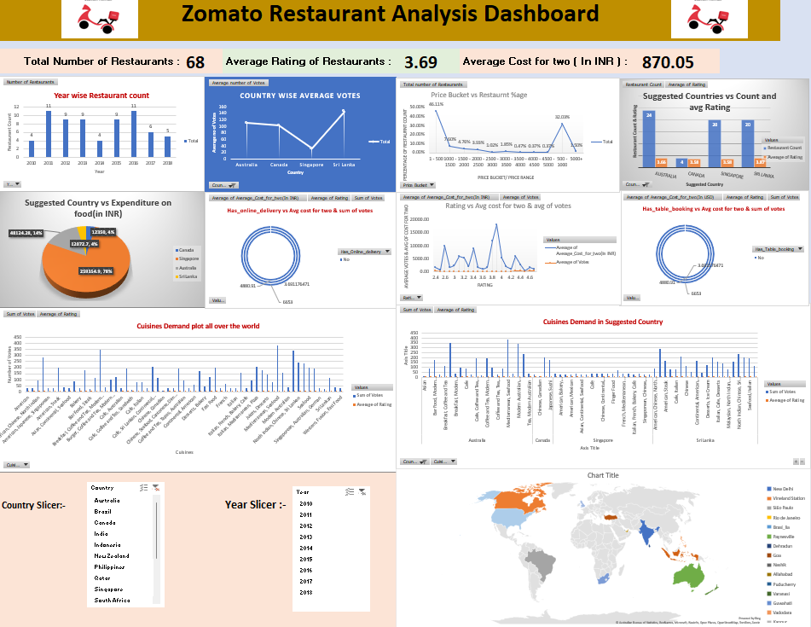

Note:-

Note: Dashboard created on Excel sheet and analysis also done on Excel sheet. For more detailed information of analysis you can refer the Excel sheet.

By: Kumar Prakash

